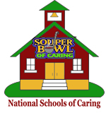
Dear Parent,
Our school is proud to announce that we are a National School of Caring. We have partnered with Souper Bowl of Caring to create a unique opportunity for our students to join in a national movement of giving and serving.
During the weeks of January 8 through February 2, students will collect donations and participate in service projects. 100% of the collection will be donated to local charities. Your child will grow in understanding how important it is to serve our community.
We are asking all parents to assist their children with participation by donating any of the following:
□ Money
□ Canned Goods
□ Other Items our community needs:

Please Make Checks Payable to: ____________________________________________

Sincerely,
_____________________________
Principal

