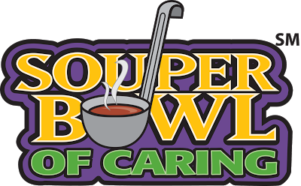

WUES Souper Bowl of Caring Food Drive is coming soon!

January 28 - February 1, 2019

Let’s TACKLE HUNGER – Fill your bag with food!

WUES families donated over 36,000 pounds of food last year to the Houston Food Bank. Let’s rise to the challenge and increase that number this year to help Houston TACKLE hunger!

DONATIONS! Please bring food items you would like to donate to the Food Drive to your classroom at drop off any day during the week of January 28th – February 1st. Items will be weighed and counted and the class with the most generous weight donation will be crowned WUES Souper Bowl of Caring Champion! Don’t forget Houston Food Bank’s most needed items (see back). The class donating the most protein points will be crowned Most Valuable Player! This is such an exciting and festive philanthropic event for our children to experience the joys of community service!

WE NEED YOUR HELP! It takes a lot of help to organize tons of food! Please consider volunteering your time in one of the following ways:

☐ Food Sorters, Food Weighers and Protein Point Counters – Have a little time to spare and need a workout? Help us sort food each morning the week of January 28 – February 1 from 7:40-8:30AM as students and parents bring their classroom donations to the MPR. Any amount of time helping is appreciated!

☐ Heavy Lifters – We need strong men and women who are ready to flex their muscles! We will need some assistance each morning, but help is especially needed on Thursday, Jan 31st - Friday February 1st from 7:40-9AM. Any amount of time helping is appreciated!

To volunteer during this exciting week, please contact the Souper Bowl of Caring Team:
Olivia Benitez (oliviajbenitez@icloud.com) or Liz Boyle (eebee@me.com)

--- OVER for donation items accepted --

January 28 - February 1, 2019

Most Needed Items

• Canned tuna or chicken, packed in water ** • Peanut butter**
• Canned stews and pasta/meat, easy on salt and fat • Packages of dried beans
• Canned fruits in light syrup, natural applesauce • 100% juice cans or boxes
• Canned vegetables, tomatoes, tomato sauce • Pasta, noodles
• Cereals and cereal bars, easy on sugar and fat
• Soups with meat and/or beans, meal-in-a-can, easy on the salt and fat

Houston Food Bank is UNABLE to ACCEPT:
• Open packages • Homemade food items • Baby food
• Expired items (yuck!) • Perishable items • Glass containers

PLEASE DO NOT INCLUDE
• 50 lb bags of rice • individual serving packages

**Protein Challenge Points
Tuna or chicken: 1 point per can (< 5oz), 2 points per family sized can (> 6oz)
Nut butter: 1 point per small jar (<16oz), 2 points per regular jar (17-28oz), 3 points per family sized jar (>28oz)

If you have any questions or concerns, please contact a member of the SBoC team.

Olivia Benitez oliviajbenitez@icloud.com
Liz Boyle eebee@me.com

