Let's Tackle Hunger
WITH SOUPER BOWL OF CARING
DEAR PARENT:
Our school is proud to announce that we are participating in the 2019 Souper Bowl of Caring!
Souper Bowl of Caring uses the energy around our nation’s largest sporting event to mobilize and inspire youth to ﬁght hunger and poverty. Students develop stronger connection to their communities as they collect food and raise money for charities that provide shelter to the homeless, food to the hungry and compassion to those in need.
During the event, students will take up a collection and give our donations to a local charity. We will report our total to Souper Bowl of Caring so our students become part of the national efforts. Through this experience, they learn the power of working together to make a difference in the lives of others.
Help us make this year’s goal a reality as we strive for 100% participation. Let’s give every student the beneﬁt of this positive learning experience!
OUR COLLECTION WILL TAKE PLACE ON:

Food
Monetary Donations
(dates of collection)
WE WILL COLLECT:

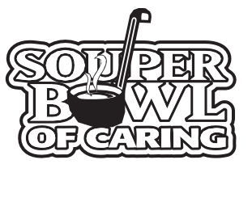
(Make checks payable to: )
Other Items:
WE WILL DONATE OUR COLLECTION TO:

(name of receiving charity)
Thank you for doing your part to make our 2019 Souper Bowl of Caring a success! Sincerely,

Principal
SM

souperbowl.org

